Web Application

# Introduction

I have been asked by my employer to develop a prototype web application, they have developed a database schema and provided it to me in order to integrate it into the web application. I will have to design and implement some user interfaces in order to display data about ‘ESport Championship’, these interfaces will have control to add, edit, and delete data from the database. I will create several pages for my application in order to display specific data from the database, this includes a player’s page, a game’s page, and a team’s page.

***Contents***

Introduction 1

Planning 3

Wireframes 3

Choosing a colour scheme 3

Research 3

Usability Survey 3

Functionality 3

Adding/removing data 3

Alert Messages 3

Conclusion 4

References 5

# Planning

## Choosing a colour scheme

If I wanted my website to stand out from others, I needed to start with finding a good colour scheme that I could follow throughout my website. After researching colour schemes and trying to figure out how to create/find a colour scheme that would fit my application, I came across a website called “[Flat UI Colours](https://flatuicolors.com/)” that contains various colours schemes, of which I selected “Flat UI Palette v1”, containing colours that would allow me to create an intuitive website where the colours of items would be meaningful to users. I believe these colours would have meaning to the user due to the gestalt principle, similarity. This principle implies that your eyes build relationships between similar elements, such as colours in this case. This information was also backed up by (Soegaard, 2022) in the quote “The human eye tends to build a relationship between similar elements within a design. Similarity can be achieved using basic elements such as shapes, colours, and size.” I kept the colours for elements consistent throughout the creation of my application in order to not deteriorate the user experience.

## Wireframes

In order to start creating my web application, I needed a plan that I could follow. For my plan, I created wireframes in order to design an initial layout for the application. They are a basic concept that allow you to easily create a base design for your website, (Hannah, 2022) agrees with this in the quote “They may seem basic enough to be overlooked, but wireframes will enable you to get vital user, client, and stakeholder approval when it comes to the layout and navigation of the product’s key pages.”. While I was creating the wireframes, I integrated the colour scheme I chose previously so that I was able to view what the colour scheme looked like in practice, doing this allowed me to conclude that I will continue to use the colour scheme throughout the project. I created a wireframe for all the pages on my website, including the add, edit, and delete forms.

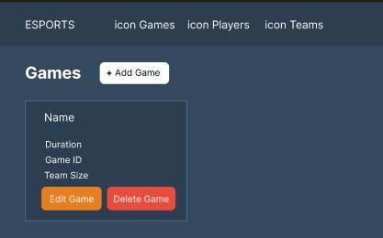

The above is the wireframe that I created for the games page, both the player’s and team’s wireframes follow a similar format to the game’s wireframe. The wireframe shows how each row of data from the database will display inside a card alongside buttons that will allow you to modify data within the database. Also included in this wireframe is my navigation bar, in development the ‘icon’ placeholders will be replaced with actual icons in order to utilize the dual coding theory, which is the idea of supporting text with images in order to support understanding of the buttons use. This has been supported by (Tes, n.d.) in “Dual coding involves presenting information in multiple different formats - for example in writing and in pictures - to support pupils’ understanding.”

# Functionality

## Adding/removing data

## Alert Messages

# Research

## Usability Survey

# Conclusion

# References

Hannah, J., 2022. *CareerFoundry.* [Online]   
Available at: https://careerfoundry.com/en/blog/ux-design/what-is-a-wireframe-guide/#conclusion  
[Accessed 15 December 2022].

Soegaard, M., 2022. *Interaction Design Foundation.* [Online]   
Available at: https://www.interaction-design.org/literature/article/the-law-of-similarity-gestalt-principles-1  
[Accessed 15 December 2022].